Namespaces and resourcequotas:

If we don’t mention any namespace while creating a pod/deployment that goes into default namespace.

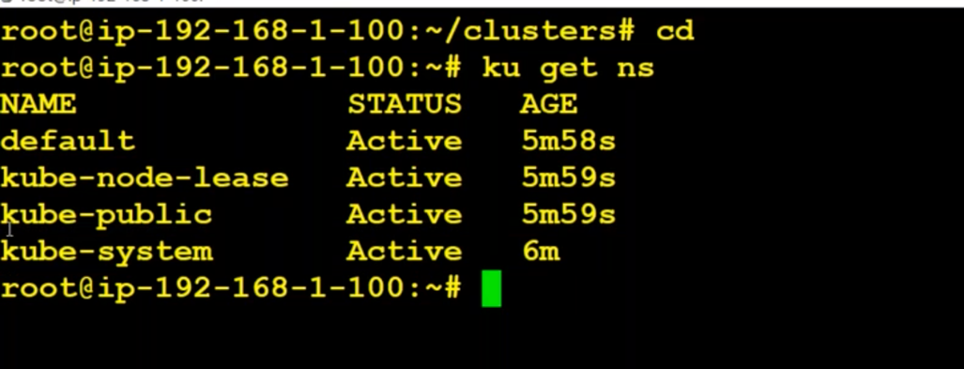

How to create namespaces ?

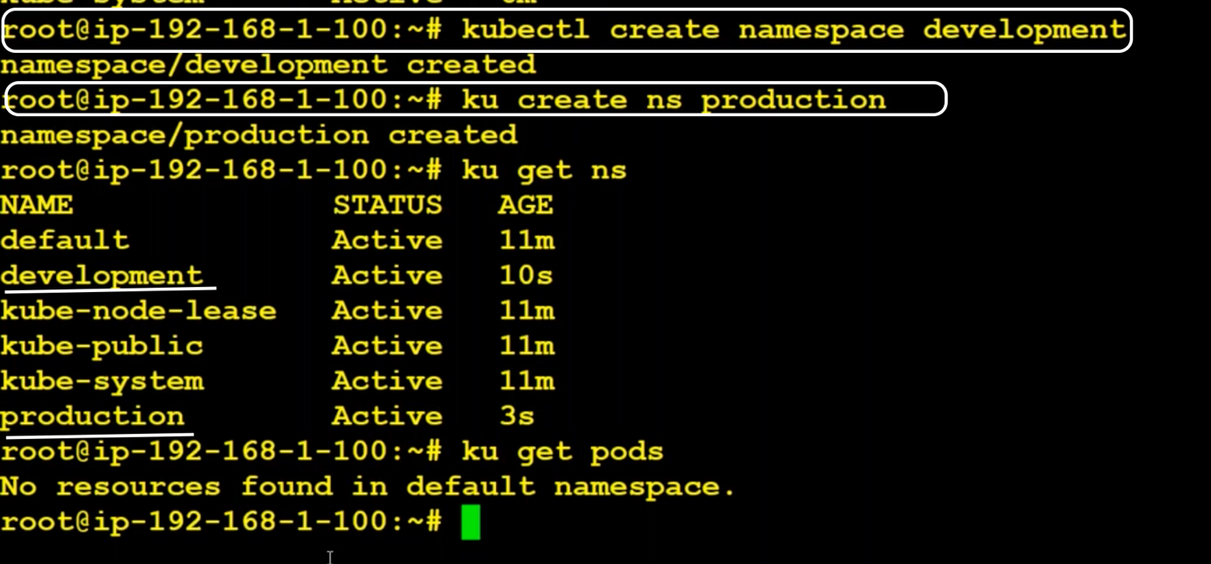

How to switch namespace ?

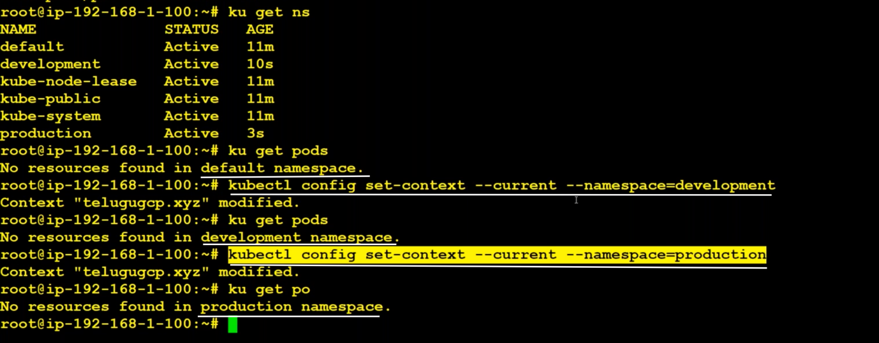

Instead of giving this much large command, we can make use of kubens.

We have to download kubens.

<https://github.com/ahmetb/kubectx>

>> wget <https://github.com/ahmetb/kubectx/releases/download/v0.9.4/kubens_v0.9.4_linux_x86_64.tar.gz>

>> tar xzvf <kubensfilename.tar.gz>

>> mv kubens /usr/local/bin

>> kubens

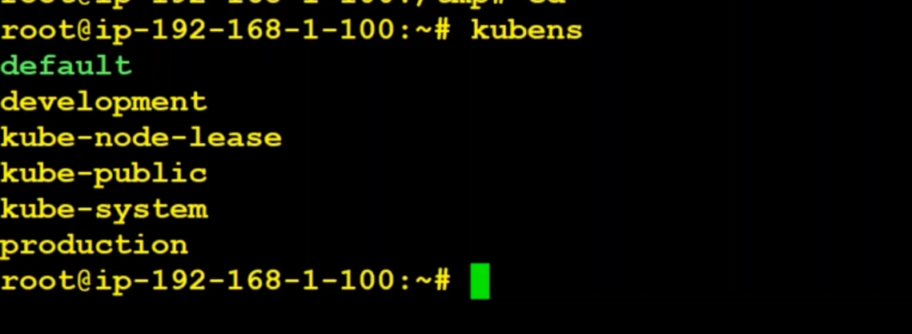

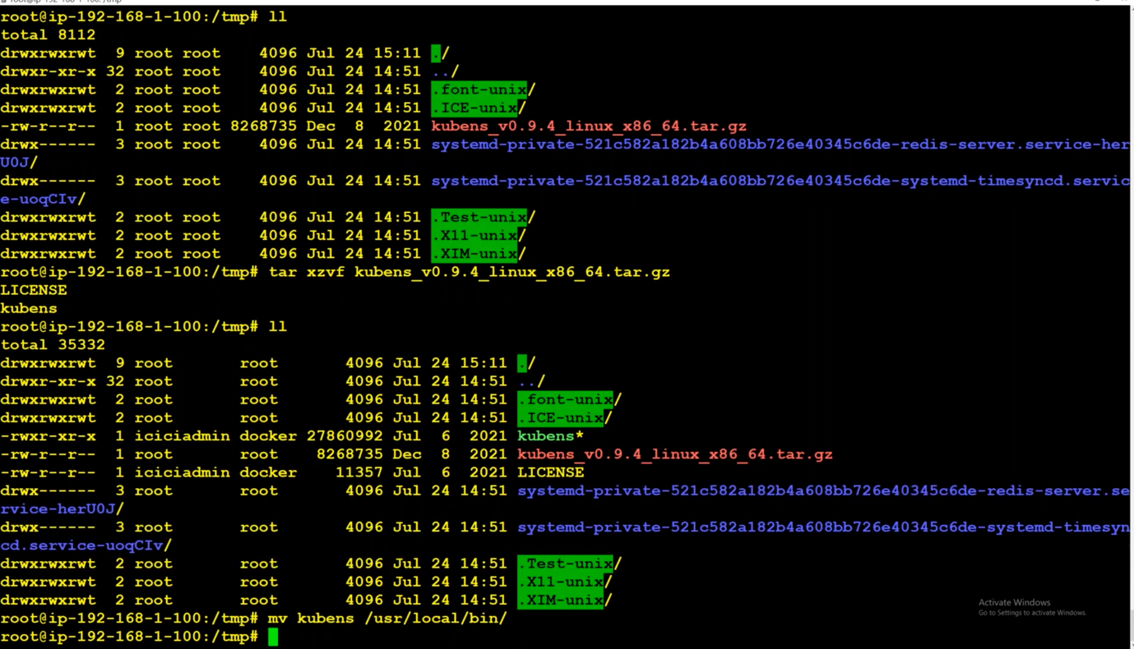

To have restrictions on namespace, we can use resource quota.

To put resource limits on individual container, use Kubernetes resource and limits associated with the pods within each namespace.

If we want to apply some restrictions on namespace, we use Resource Quotas.

If we want to apply some restrictions on pods/containers, we use request and limits.

Kubernetes supports 2 CPU quotas:

( One Millicores is 1/1000 of a CPU, therefore 1000m equals 1 CPU. 1000m equals one CPU on all computers. )

requests --> a Pod requests an amount of CPU resources

limit --> a Pod defines the limit of CPU resources it will use

If the node where a Pod is running has enough of a resource available, it's possible (and allowed) for a container to use more resource than its request for that resource specifies. However, a container is not allowed to use more than its resource limit.

When kube-scheduler is scheduling a pod, it will check for the minimum resoures. That is request.

If deployments are not creating and we don’t find the issue by giving

kubectl describe deployment <deploymentName>

we can use kubectl get events

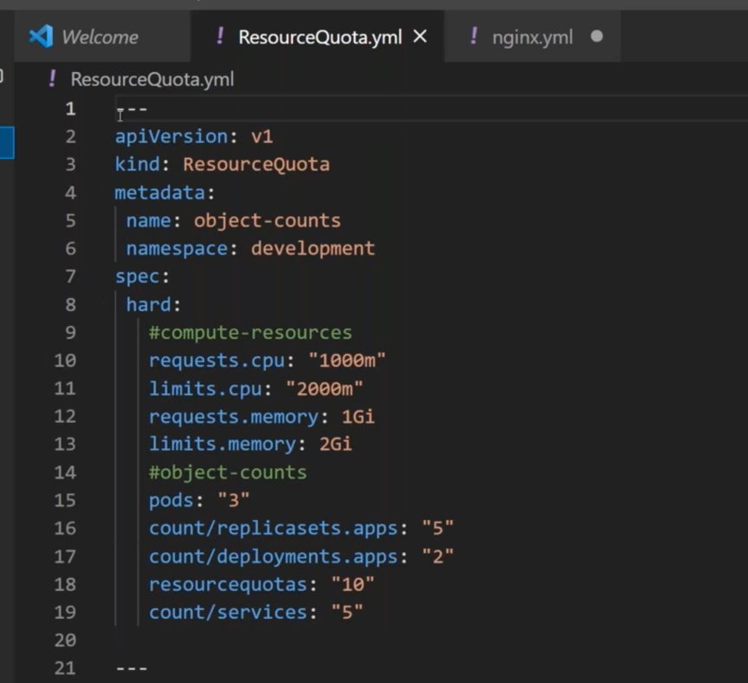

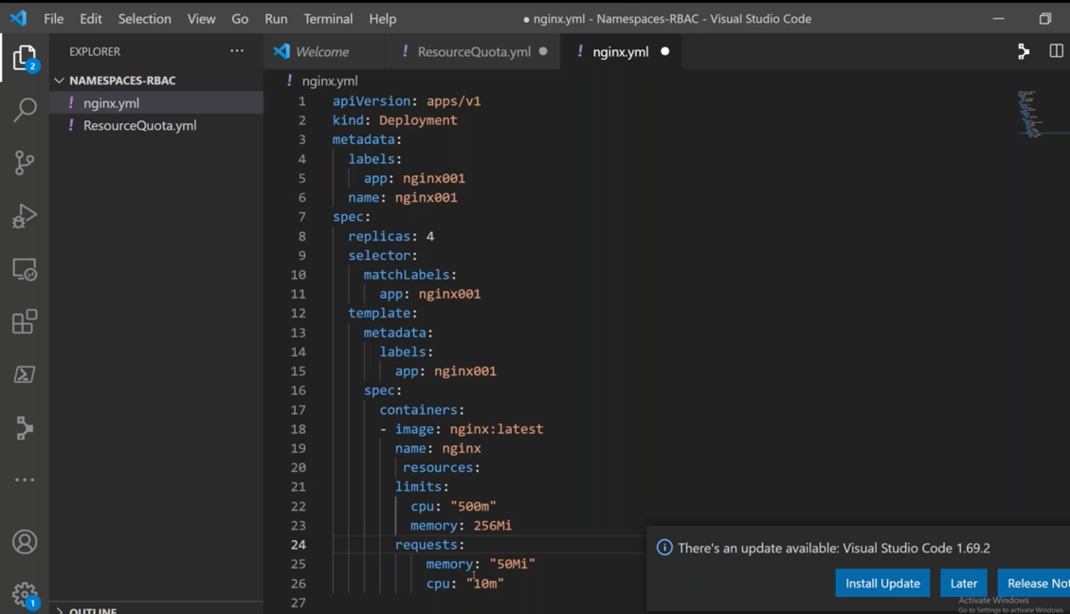

If we want to constrain resource allocation on container we can specify in the deployment itself under spec.

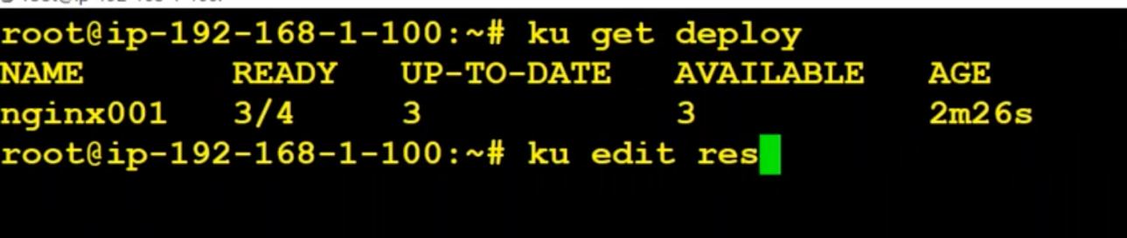

Creation of third pod is contrained as we have given quota for pods as 3.

LimitRange:

Limitrange is a policy to constrain resource allocation(to pod or container) in a namespace.

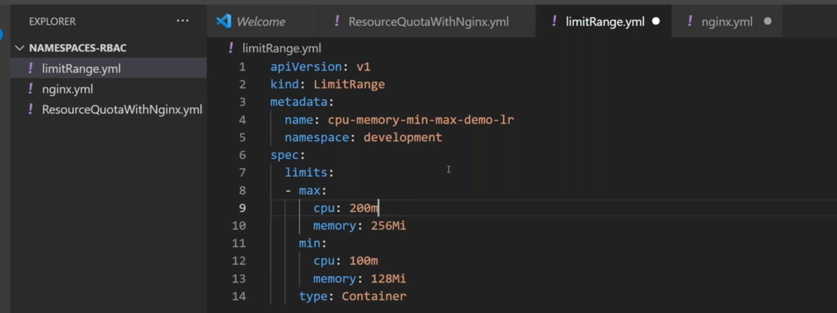

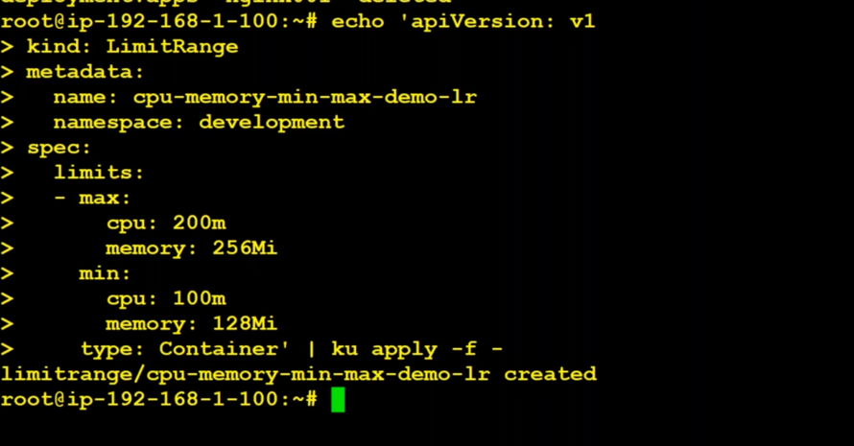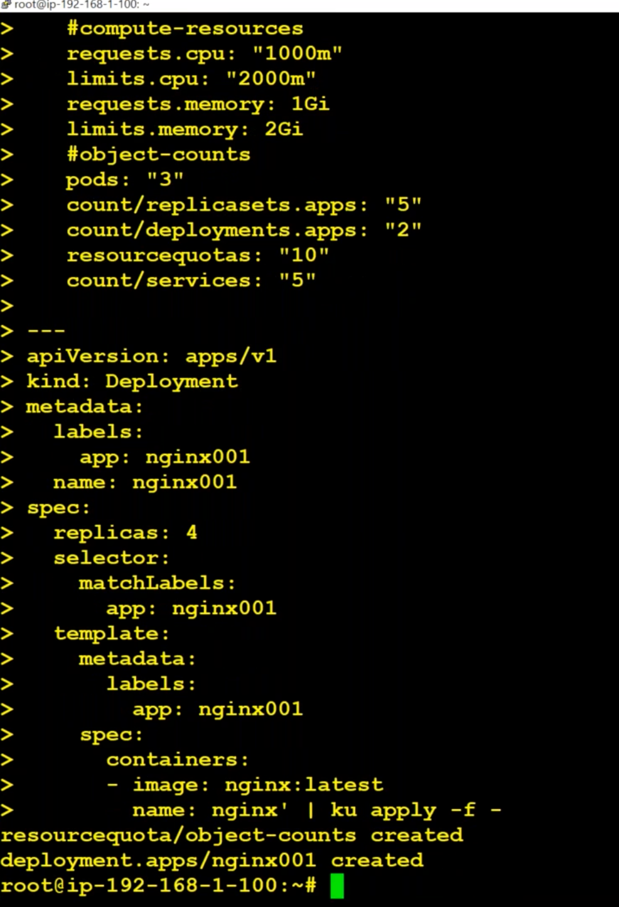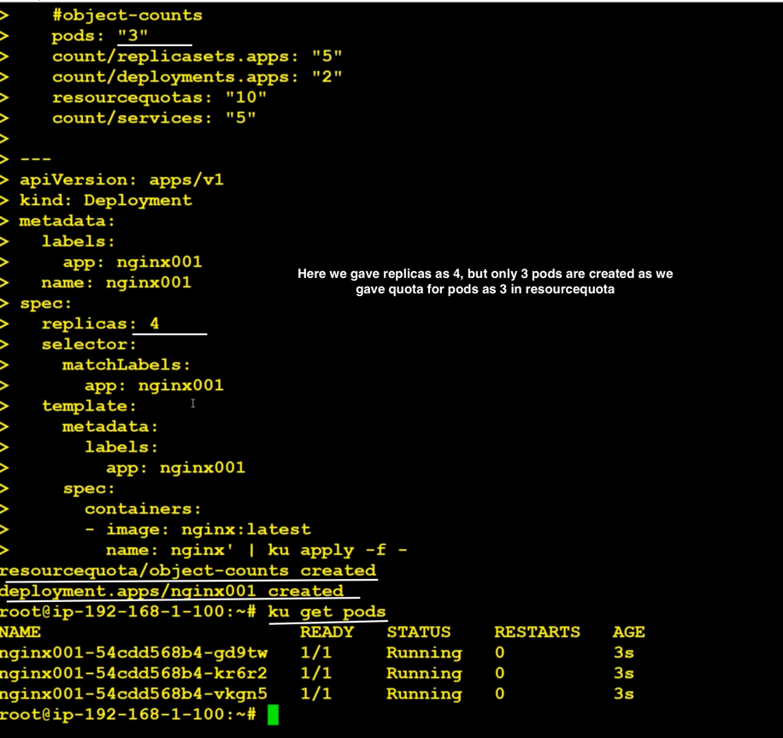

Change quotas of pods from 3 to 30 and then check it.

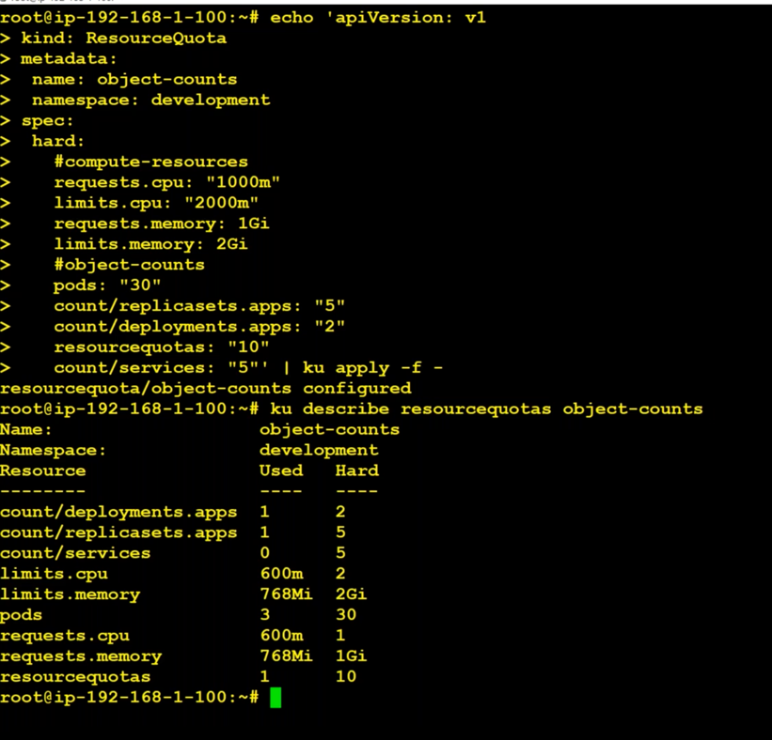

To check limit range:

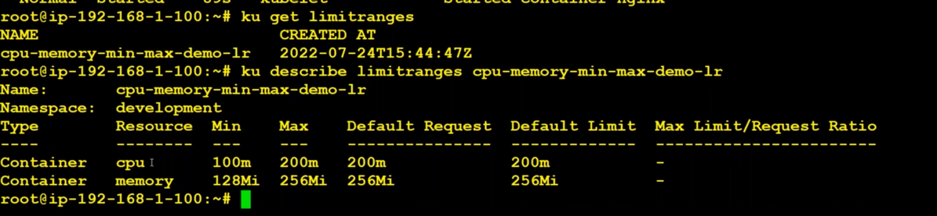

**\*\*No need to provide default and default values when min and max are given because by default the POD/Container will take max CPU, Memory as default.**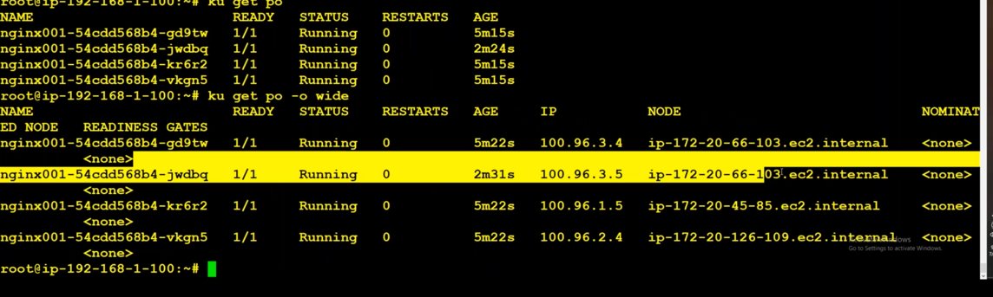

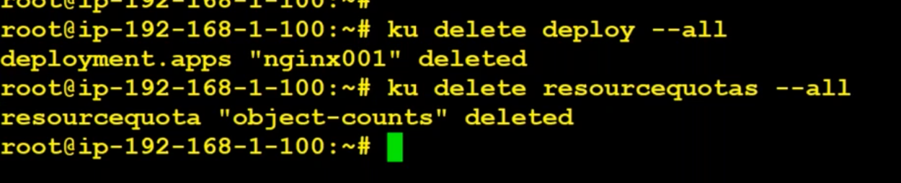

config file kept in : cat .kube/config

RABC (Role Base Access Control) :

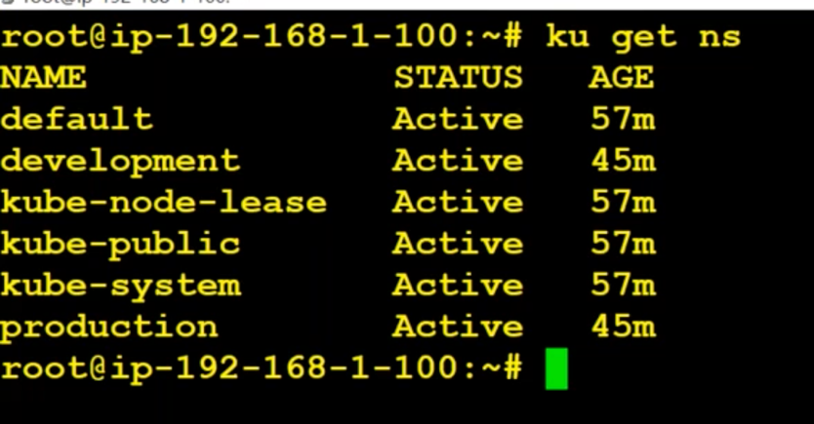

User account : used by admin and developer for management and deployment.

Why user accounts ?

Suppose we have two users(anand and sameer). We want anand to work only on development and Sameer to work only on production. This can be achieved by creating user accounts.

For authentication and authorization, we have IAM in AWS and Azure ID in Azure.

Here in Kubernetes we don’t have anything by default.

Open s3 bucket. We can find s3 bucket details of the cluster using

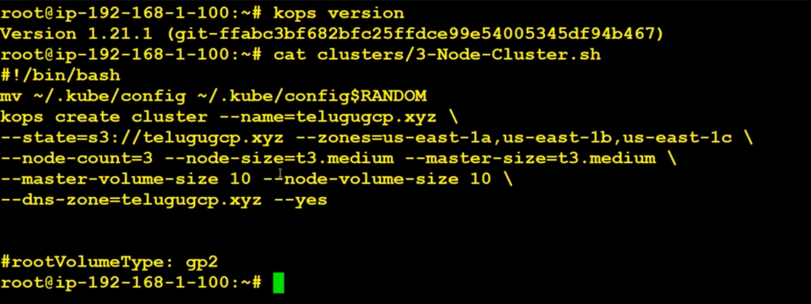

Download .crt and .key files from s3bucket and store it in our local.

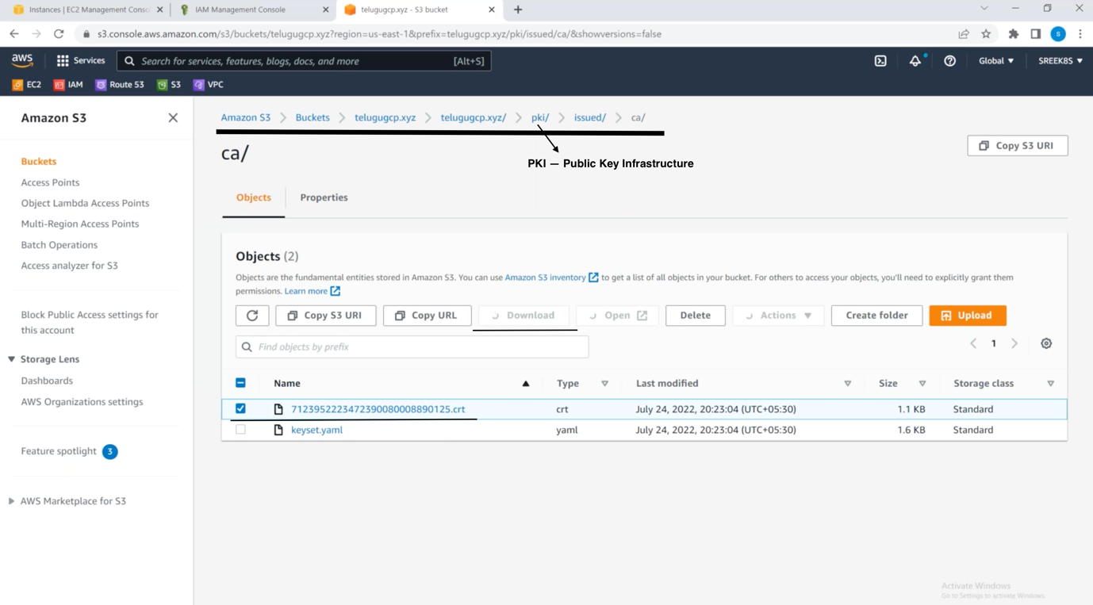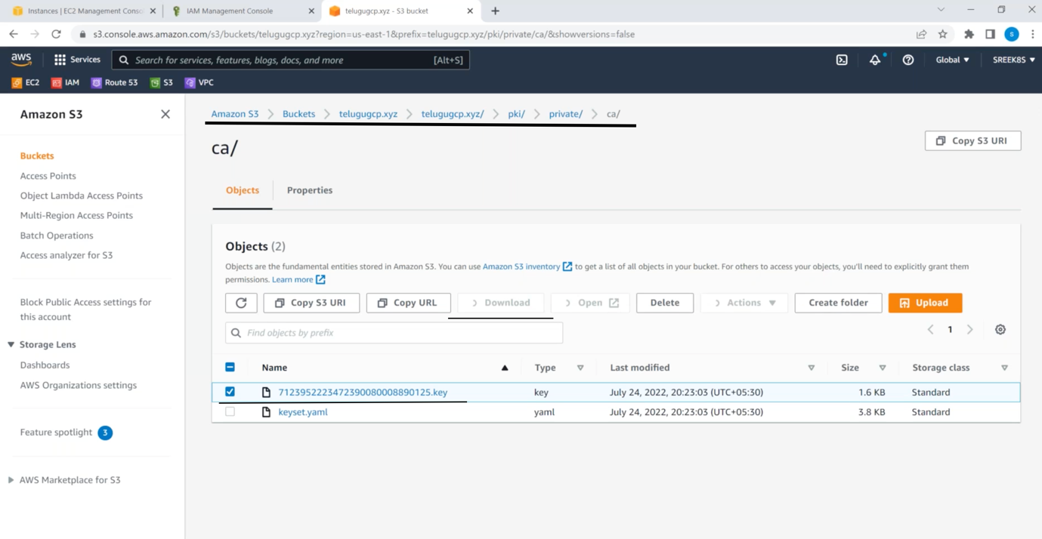

We are going to create userId with the help of these files only.

Copy .crt file into CA.crt which is in linux vm where cluster is running.

Copy .key file into CA.key which is in linux vm where cluster is running.

Create anand.key and create anand.csr from anand.key file

openssl genrsa -out anand.key 2048

openssl req -new -key anand.key -out anand.csr -subj "/CN=anand/O=development"

sign anand.crt file

openssl x509 -req -in anand.csr -CA CA.crt -CAkey CA.key -CAcreateserial -out anand.crt -days 45

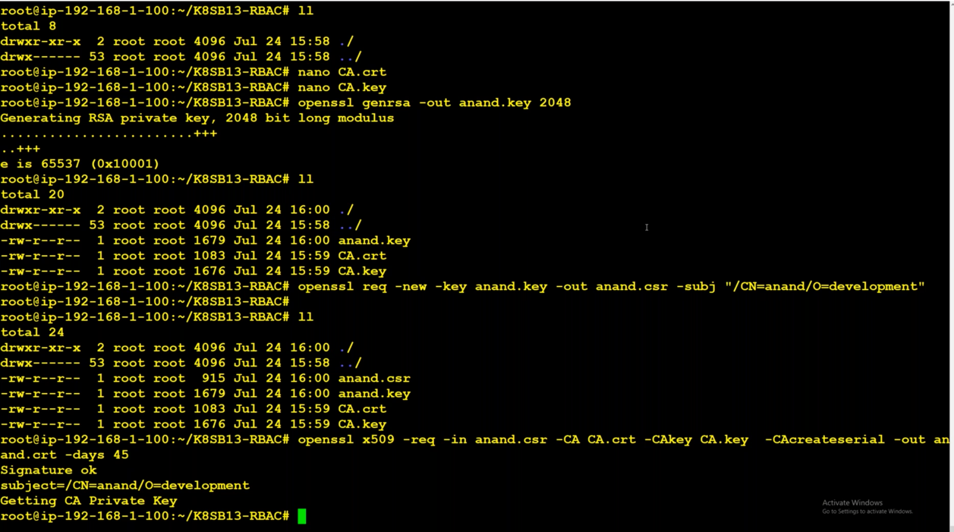

Create private .key file and .csr file from .key file and then sign .csr file and generate .crt file

openssl genrsa -out bala.key 2048

openssl req -new -key bala.key -out bala.csr -subj "/CN=bala/O=development"

openssl x509 -req -in bala.csr -CA CA.crt -CAkey CA.key -CAcreateserial -out bala.crt -days 45

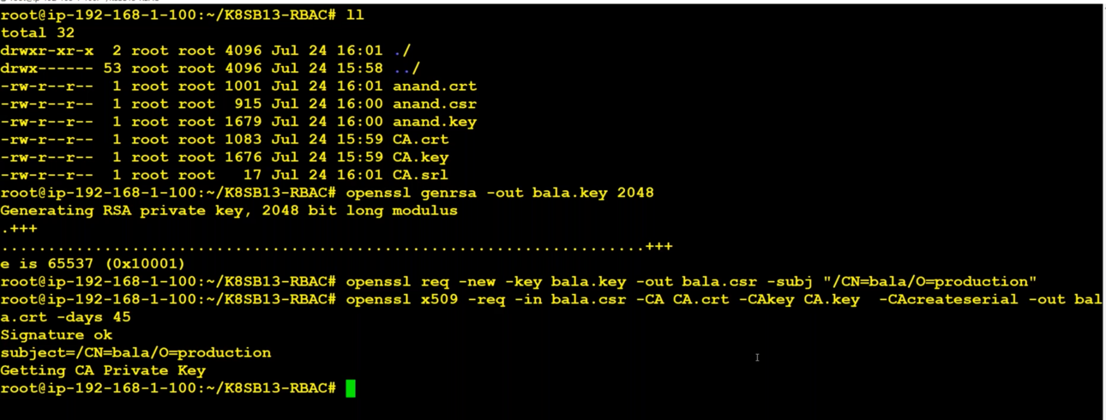

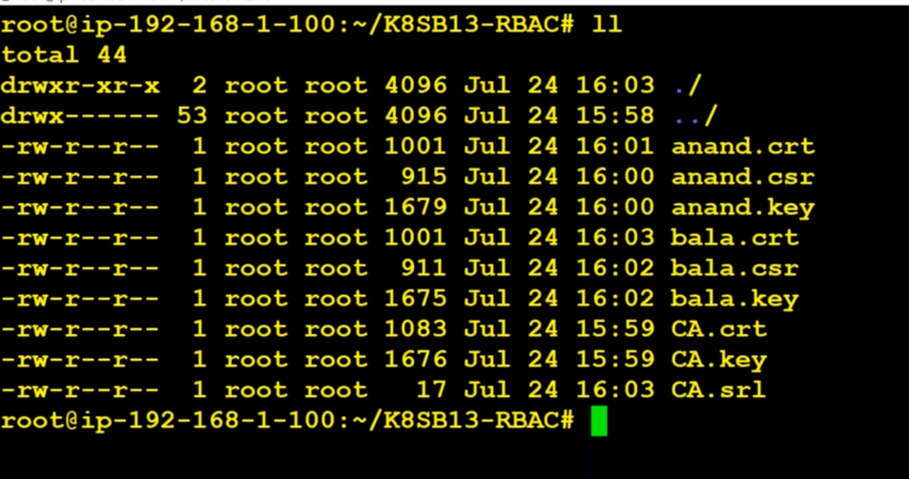

After creating the .crt for bala and anand. We have to copy them.

Open config file:

>> cat ~/.kube/config

Copy the content of config file into anand-kubeconfig.yml. It looks like:

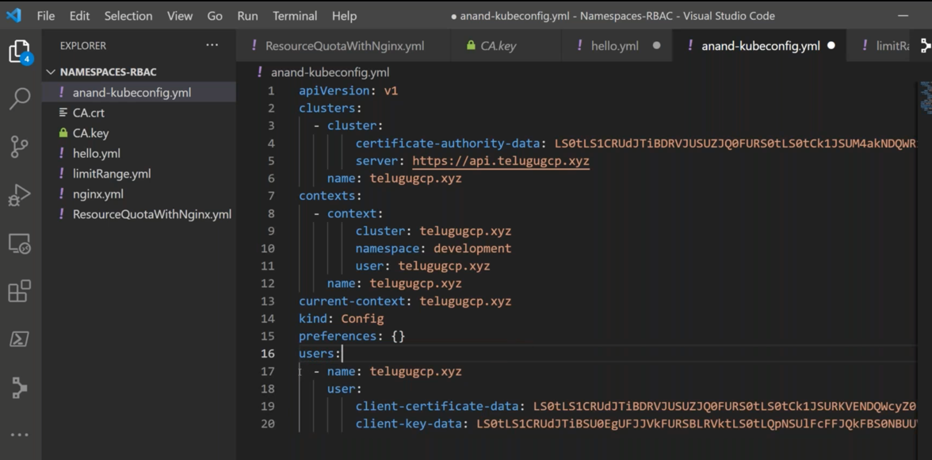

We have to change the user details:

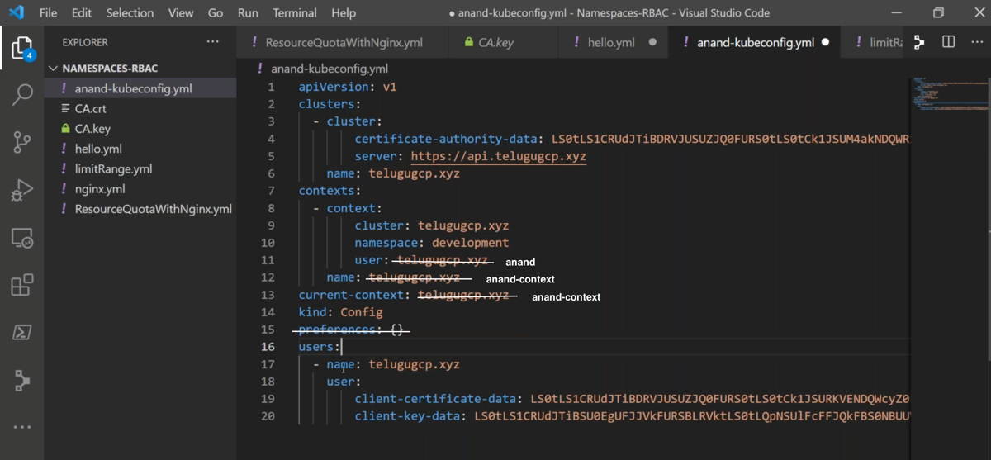

In above picture change users also like below:

users:

- name: anand

user:

client-certificate: anand.crt

client-key: anand.key

Create a new ubuntu machine as the existing one contains everything.

Download kubectl.

curl -LO "https://dl.k8s.io/release/**$(**curl -L -s https://dl.k8s.io/release/stable.txt**)**/bin/linux/amd64/kubectl"

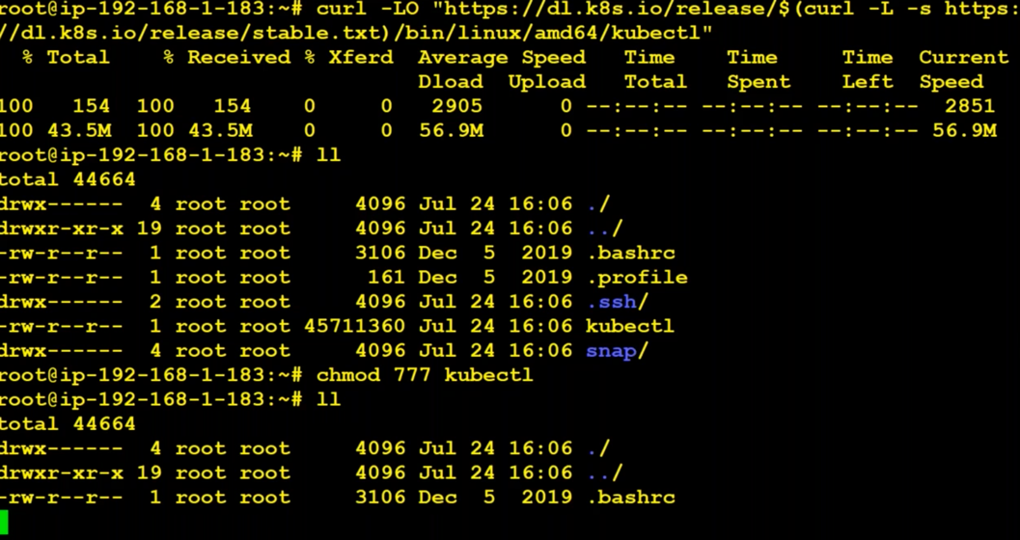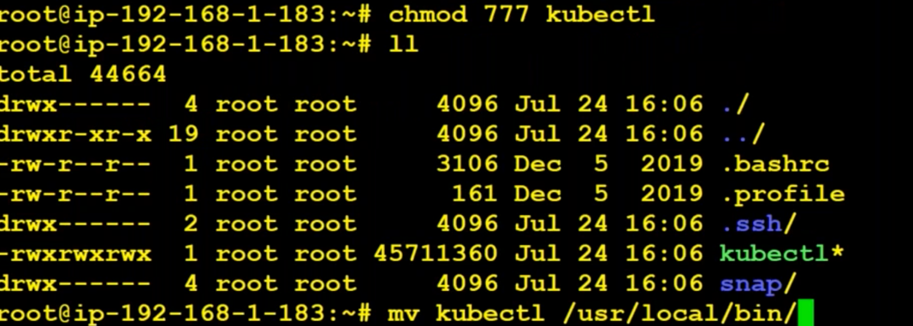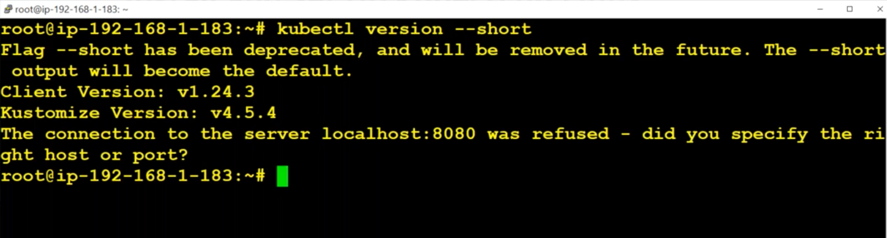

Create a folder named anand, then copy the content of anand.key and anand.crt files from old vm.

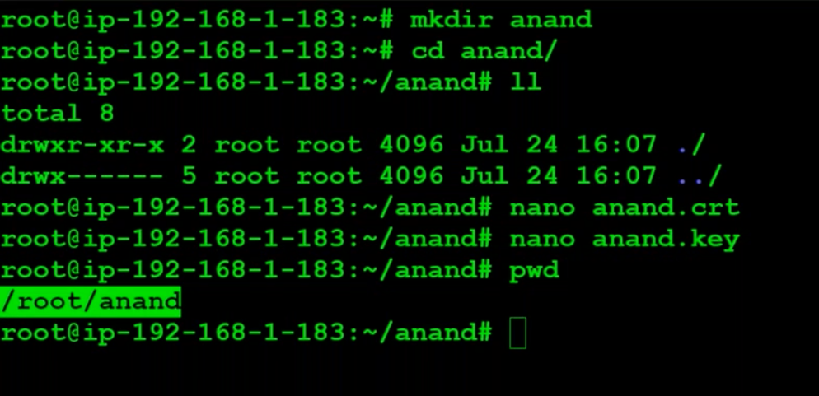

Use pwd command to know the path of the anand.crt and anand.key and then give the same values in the yml file for properties client-certificate and client-key.

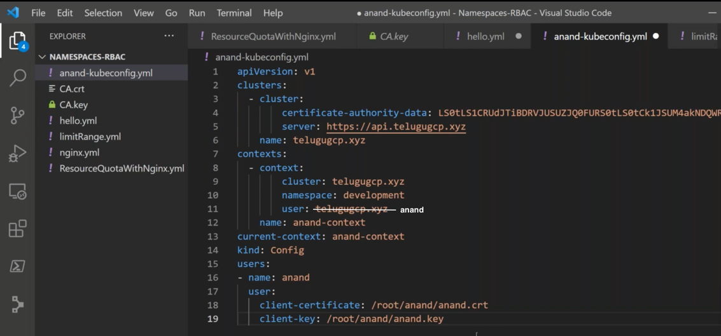

Copy the content of anand-kubeconfig.yml into config file which is in new vm where only kubectl got installed.

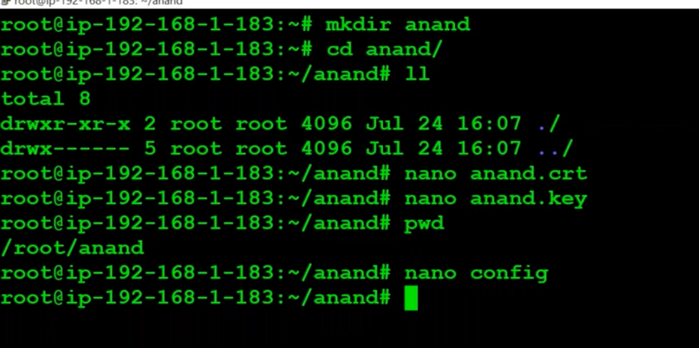

Export the config file:



Use alias:



Try to see the pods using “kubectl get pods”. If it asks for password, it means something went wrong in the config file.

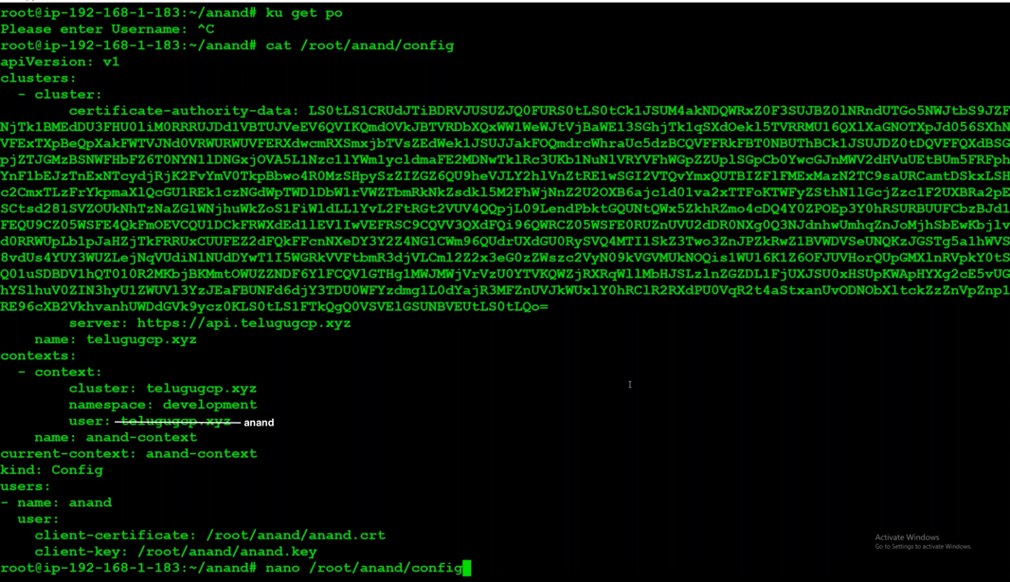

In the config file user value is given wrong. It should be anand. Modify it and use “kubectl get pods”.



Open config file and add x to the certificate-authority-data and then access the pods.



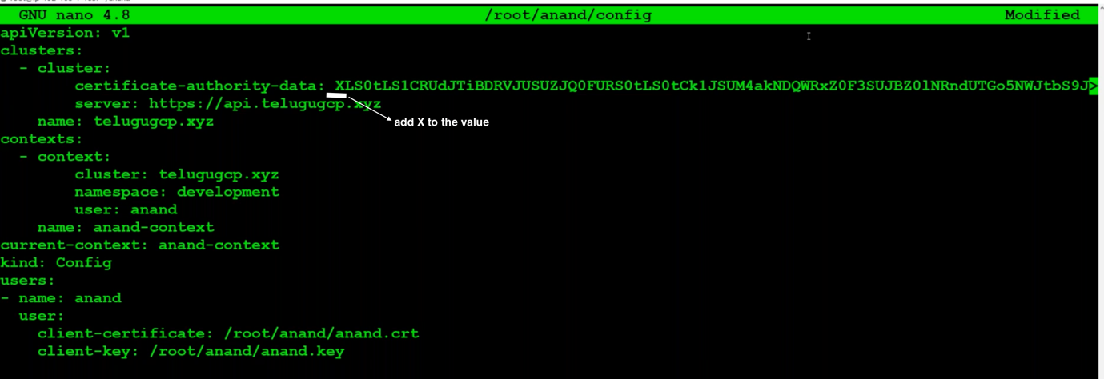

We get error because we have modified the certificate.



The difference between two errors is

The forbideen error means authentication done and failed at authorization stage. Anand don’t have access. So he got that error.

The second error is because we have modified the certificate.

**How can we provide access for anand ?**

We can use

Roles – namespace scoped

ClusterRoles – cluster scoped

Rolebinding – namespace scoped

ClusterRoleBinding – cluster scoped

To know what are allowed for Roles and Cluster. We can use command

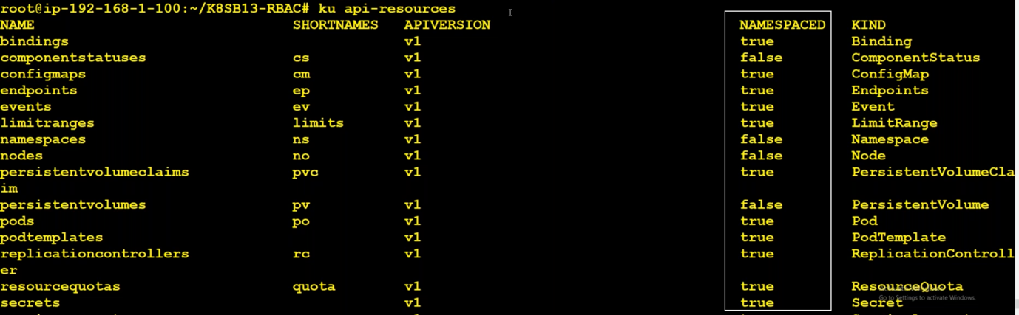

The below command gives all the things that are scoped to namespace.

>> kubectl api-resources –namespaced=true

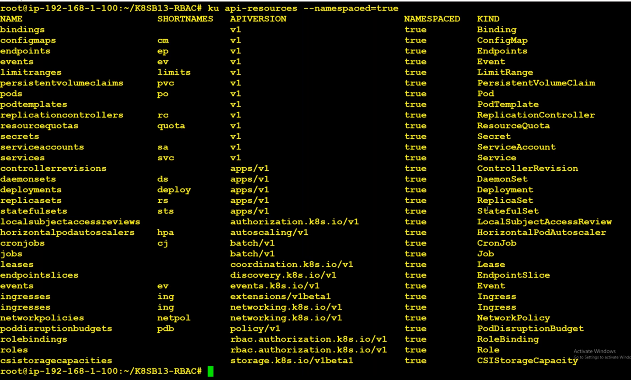

The below command gives all the things that are scoped to cluster

>> kubectl api-resources –namespaced=false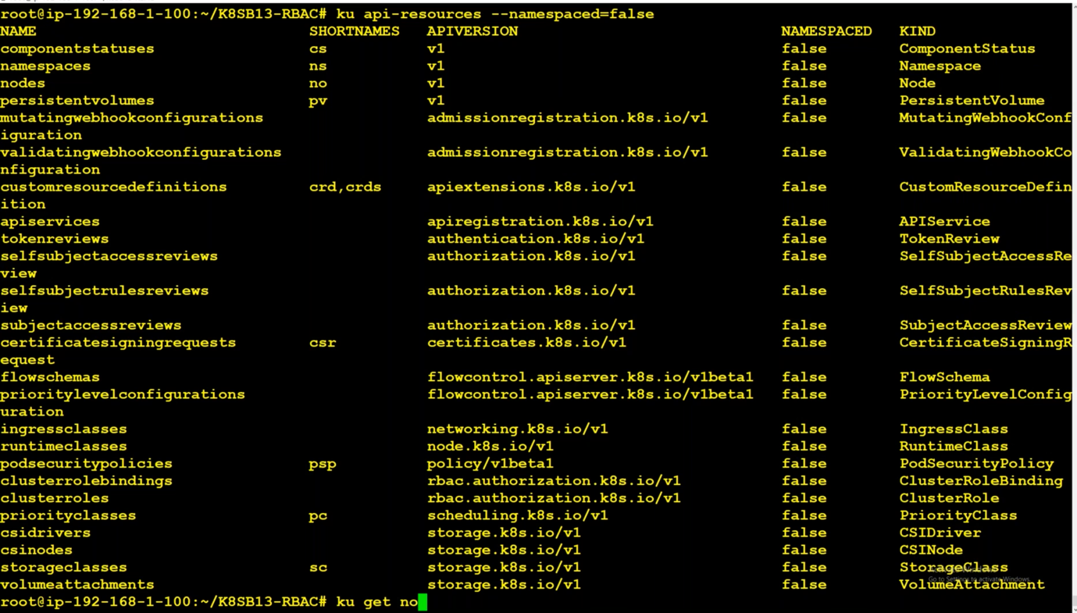

We have to create a role and then bind it using rolebinding.

kind: Role

apiVersion: rbac.authorization.k8s.io/v1

metadata:

name: anand-role

namespace: anand

rules:

- apiGroups: ["", "extensions", "apps"] # "" indicates the core API group for eacho use '' not "".

resources: ["pods", "deployments", "replicasets"]

verbs: ["get", "update", "list", "create", "delete"]

Where **apiGroups** comes from below picture **APIVERSION**. **Resources** comes from **Names.**

Do role binding also.

kind: Role

apiVersion: rbac.authorization.k8s.io/v1

metadata:

name: anand-role

namespace: development

rules:

- apiGroups: ["", "extensions", "apps"] # "" indicates the core API group for eacho use '' not "".

resources: ["pods", "deployments", "replicasets","services","secrets","events"]

verbs: ["get", "update", "list", "create"]

---

kind: RoleBinding

apiVersion: rbac.authorization.k8s.io/v1

metadata:

name: anand-RoleBinding

namespace: development

subjects:

- kind: User

name: anand

apiGroup: rbac.authorization.k8s.io

roleRef:

kind: Role

name: anand-role

apiGroup: rbac.authorization.k8s.io

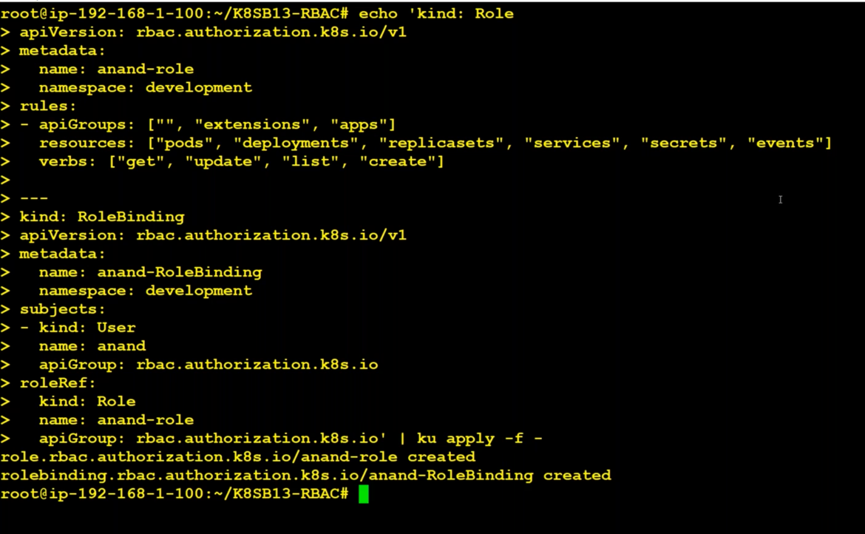

Admin have to create a role and bind it using roleBinding. Then only anand can able to access the pods, deploy, anything that admin has given access to.

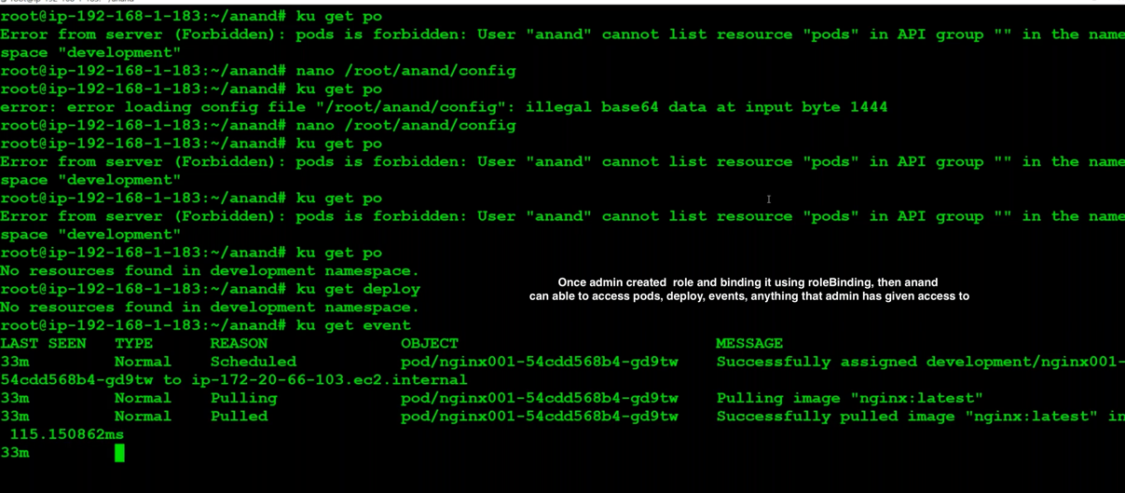

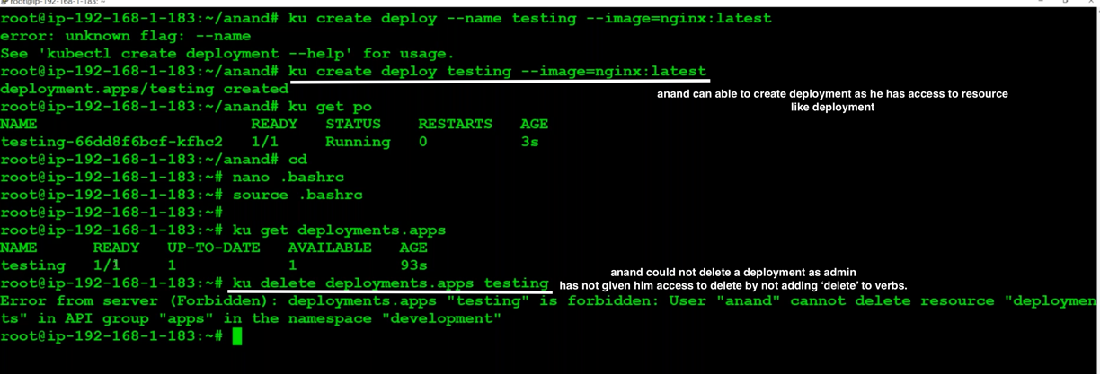

If we add delete, anand can able to delete deploy/anything

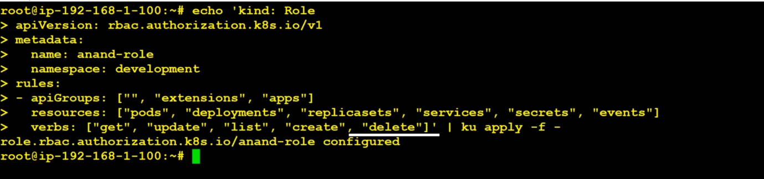

Now, anand can able to delete the deployment.



**Create user account for bala :**

First copy the contents from bala.key and bala.crt into the same files(by creating) in new vm where only kubectl installed.

Open config file:

>> cat ~/.kube/config

Copy the content of config file into bala-kubeconfig.yml. It looks like:



Modify this like :

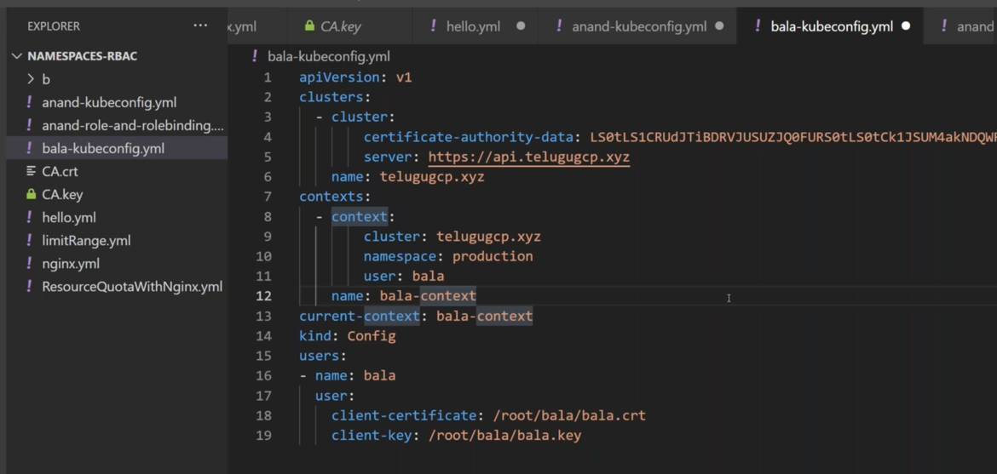

Copy the content of anand/bala-kubeconfig.yml file to config file in new vm where only kubectl is running.

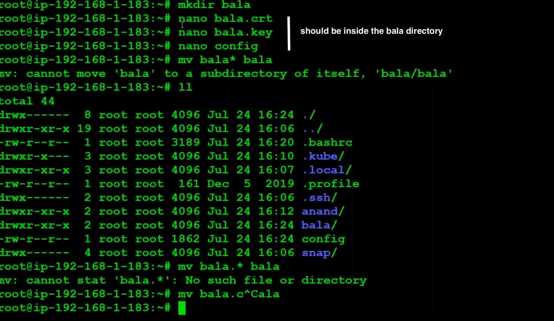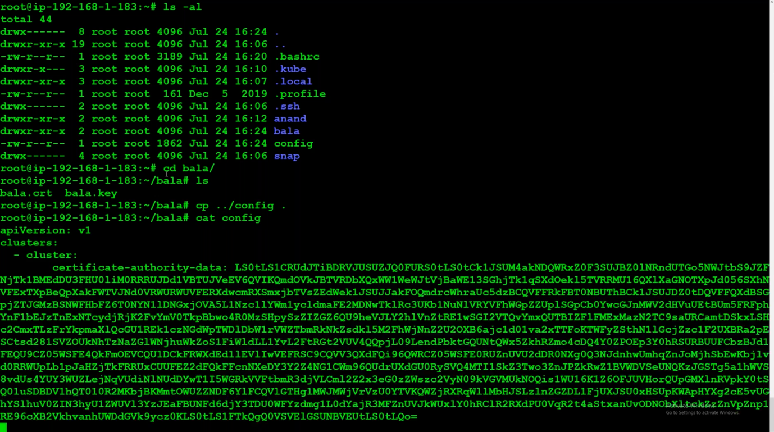

Export config file and get the pods using

>> kubectl get pods

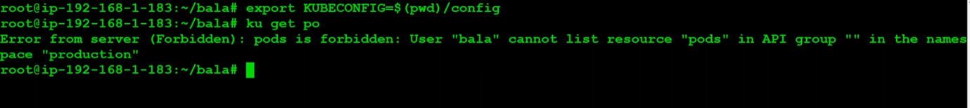

Forbidden because admin has not given any access to bala.

To give access, admin has to create roles and bind roles using roleBinding.

kind: Role

apiVersion: rbac.authorization.k8s.io/v1

metadata:

name: bala-role

namespace: production

rules:

- apiGroups: ["", "extensions", "apps"] # "" indicates the core API group for eacho use '' not "".

resources: ["pods", "deployments", "replicasets","services","secrets","events"]

verbs: ["get", "update", "list", "create"]

---

kind: RoleBinding

apiVersion: rbac.authorization.k8s.io/v1

metadata:

name: bala-RoleBinding

namespace: production

subjects:

- kind: User

name: bala

apiGroup: rbac.authorization.k8s.io

roleRef:

kind: Role

name: bala-role

apiGroup: rbac.authorization.k8s.io

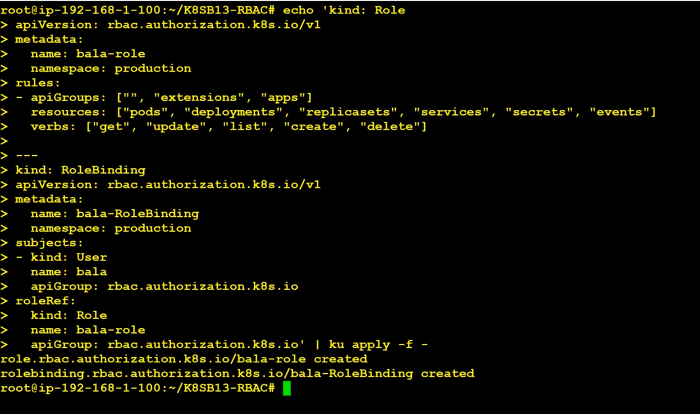

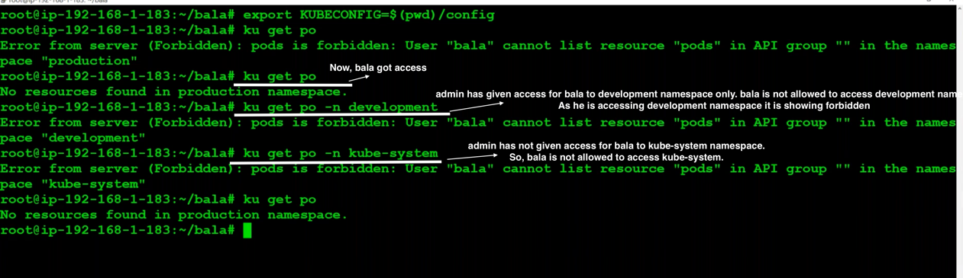

**Now, we want to provide access to both production and development for bala.**

We have to create one more context while creating bala kubeconfig file.

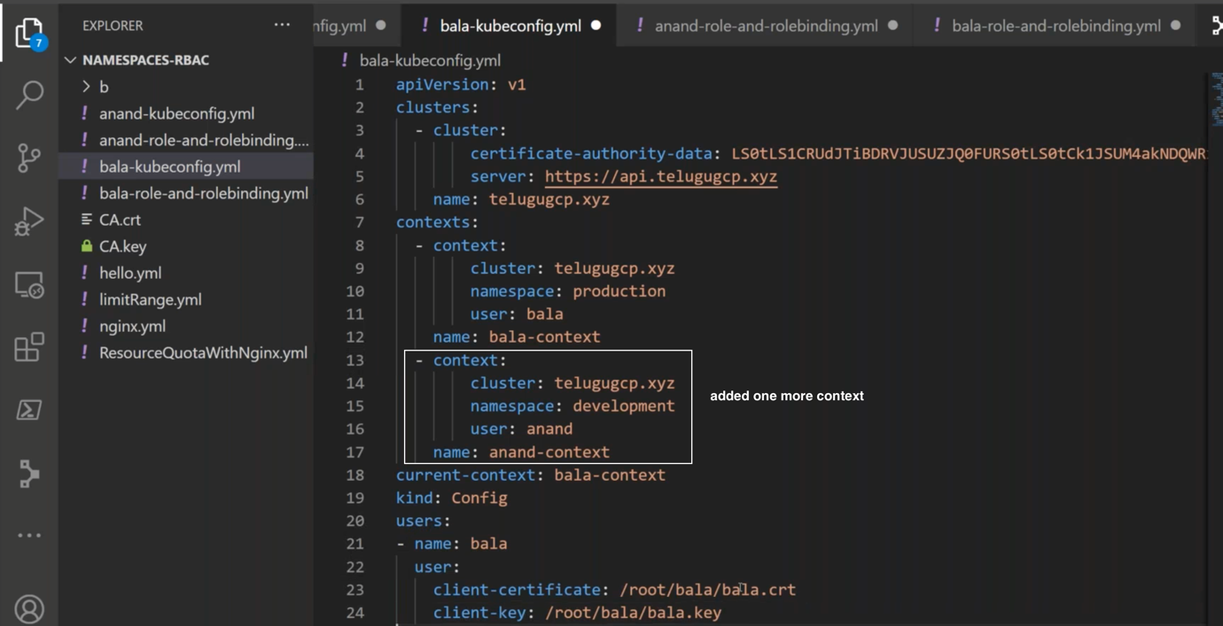

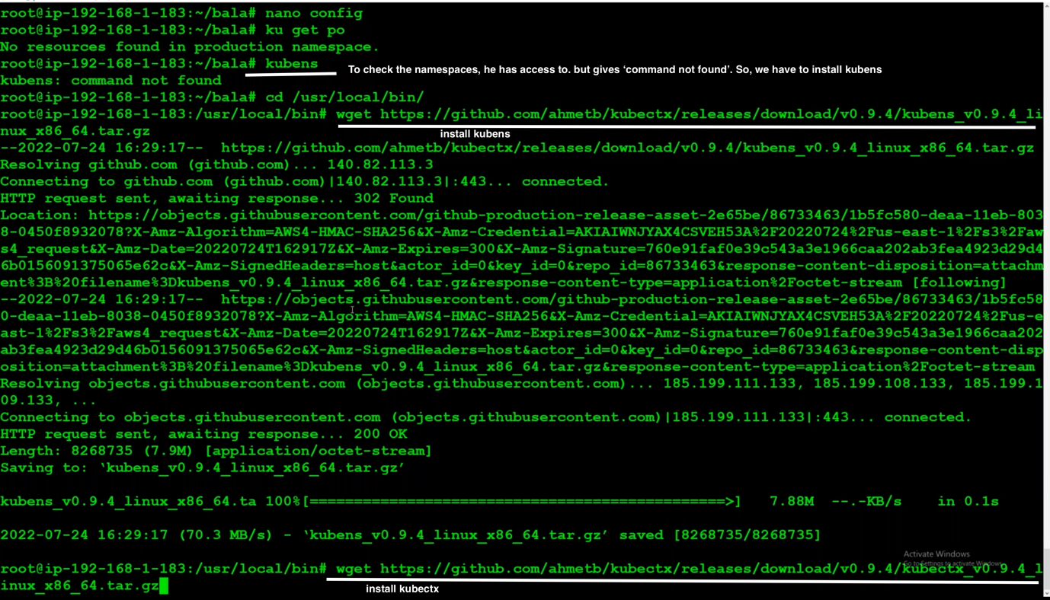

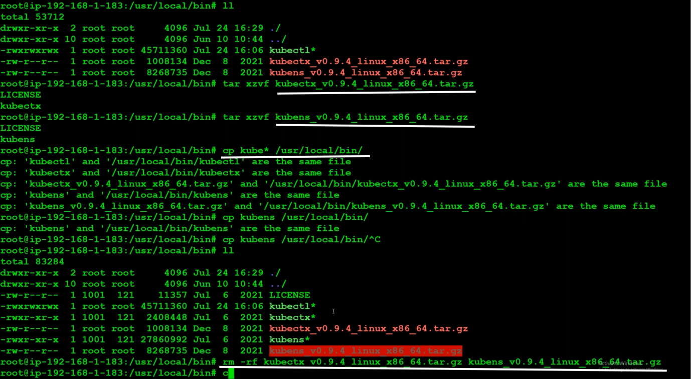

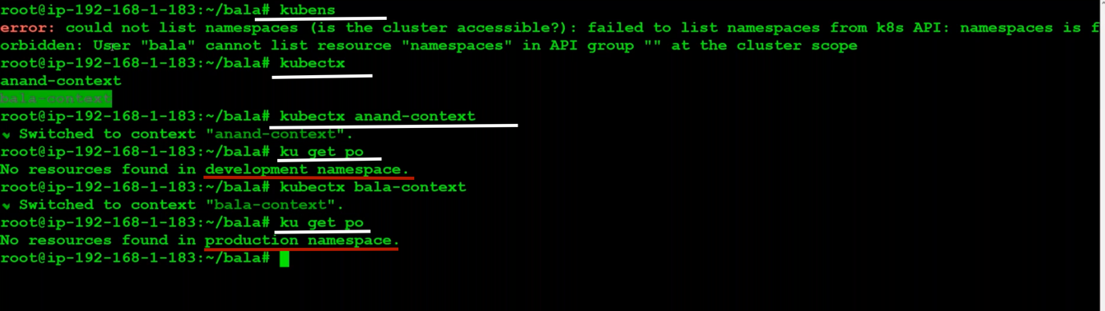

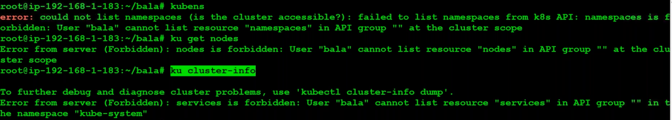

Bala don’t have access to cluster level/admin level. So, it is showing forbidden.

**How can we give cluster admin role to bala ?**

We have to create a ClusterRole and ClusterRoleBinding.

apiVersion: rbac.authorization.k8s.io/v1

kind: ClusterRole

metadata:

name: new-cluster-admin-role

rules:

- apiGroups: ["*"]

resources: ["*"]

verbs: ["*"]

---

kind: ClusterRoleBinding

apiVersion: rbac.authorization.k8s.io/v1

metadata:

name: ClusterRole-Bala

subjects:

- kind: User

name: bala

apiGroup: rbac.authorization.k8s.io

roleRef:

kind: ClusterRole

name: new-cluster-admin-role

apiGroup: rbac.authorization.k8s.io

---

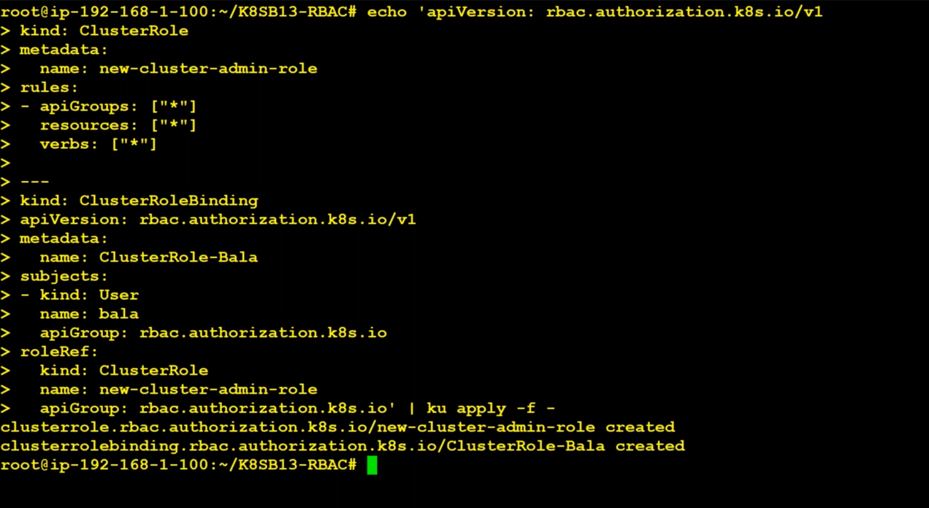

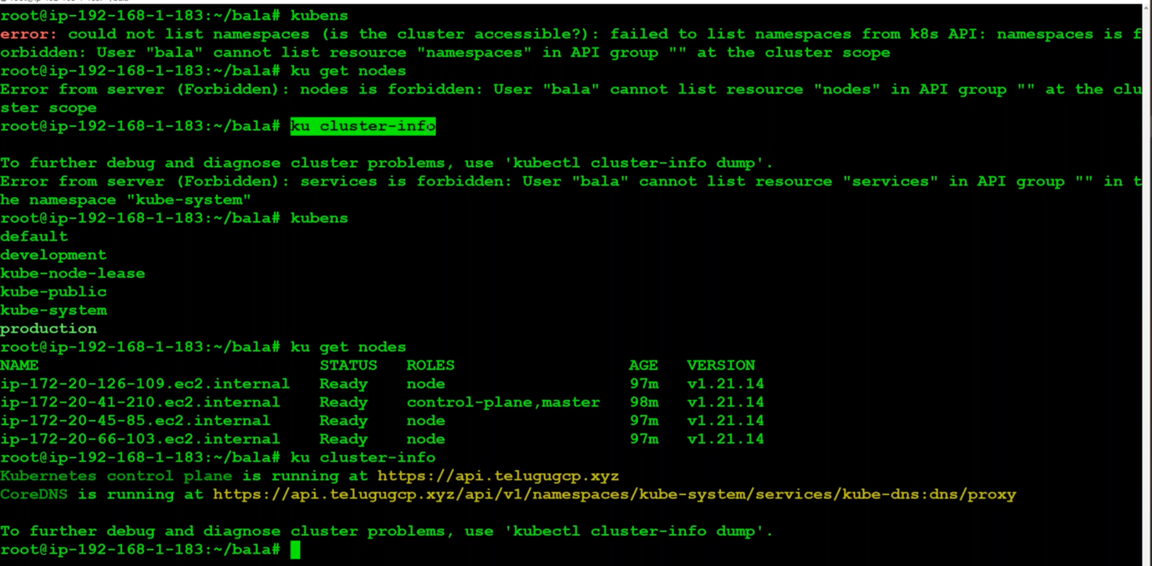

Document -- User-Access-to-Cluster.docx

Service accounts : used by pods to access Kubernetes api.

Useraccounts means having access key and password kind of thing.

Service accounts are similar to IAM Roles.